ECSC CPT ASSIGNMENT COURSE

WORK REPORT FOR CLASS CREDIT

INDUSTRIAL PRACTICE PROGRAMS

ERIK JONSSON SCHOOL OF ENGINEERING AND COMPUTER SCIENCE

ENGINEERING AND COMPUTER SCIENCE COMPLEX, SOUTH, SUITE 2.502

THE UNIVERSITY OF TEXAS AT DALLAS

SUMMER 2017 Work Report Due Date is MONDAY, AUG 07, 2017

Students are required to submit a Work Report to satisfy the ECSC course requirement.

Failure to submit a Work Report by the deadline will result in a failing grade in the course, dismissal from the Jonsson School IP Programs and loss of future privileges to accept an internship through the Curricular Practical Training Program.

The purpose of this requirement is to assure that students receive the greatest possible educational value from the work experience. In preparation for the 4-part report students must evaluate their position, apply applications of principles learned in the classroom, and in general, think clearly and objectively about the work experience.

1. Cover Sheet- Complete all data on the form
2. Performance Appraisal Form (Supervisor)-have your immediate supervisor complete the Performance Appraisal Form and return it to you.
3. Performance Appraisal Form (Student) -complete the Student Self-Evaluation Form.
4. Narrative–in composing the Narrative, you need not restate your position description from the cover sheet. The narrative should be a detailed report of the IPP experience, rather than a generalized discussion. It is academic dishonesty if you copy a narrative from one semester to another. A new Narrative must be written for each IPP work period.

All reports should be typed. Reports, which are incomplete, grammatically incorrect, or unsatisfactory must be rewritten, completed, and resubmitted for approval.

THE NARRATIVE

The Narrative is a 4-6 page, double-spaced, typed paper summarizing the work experience. Use only one side of 8 ½” by 11” paper. Care should be taken to organize the Narrative. Proper headings should be used at the beginning and for the main and sub-divisions.

*The first Narrative written for a new IPP assignment should contain an Activity Description and an Analysis Section. The suggested contents of each of these sections are listed below and you should incorporate topics you select into a narrative essay format.

*Other formats such as bulleted outlines or Q/A briefings are not acceptable, graphic images are acceptable as an addition to the 4-6 page narrative:

Activity Description: What projects did you work on? What were the objectives of these projects?

What were your project responsibilities? What problems did you encounter?

How did you solve the problems? What did you do to complete your responsibilities?

Analysis Section: What did you learn?

How did the projects and responsibilities relate to theory learned in the classroom?

How will the experience help you back in classes? On your next assignment?

After you graduate? As a professional?

What might you have done to improve your performance on this assignment?

**If this is your second or a subsequent assignment with the same department and the same organization, your Narrative should NOT repeat content from previous report. It may deal with topics such as these:

A. A special project you have been active in L. Professional ethics

B. The impact of new technology M. Authority

C. The history of the company or organization and its place N. Cultural influences

in industry, business, or government O. Industry Trends/Competitors

D. Type of organization and company policies P. Supervision

E. The work of your department and how it contributes to the firm Q. Success and failure

F. Methods employed to build efficiency and morale R. Leadership

G. Administrative decision making S. Communication

H. Employer-Employee relations T. Attitudes

I. Problem solving techniques U. Financial resources

J. Human resources and their utilization V. Organization

K. Conformity W. Discipline

***If this is your third or more subsequent assignment with the same department and the same organization, you are required to make a personal PowerPoint presentation with IPP staff, using topics as mentioned above.

Due date for oral presentation is MONDAY, AUGUST 07, 2017

Please contact your internship coordinator to schedule a presentation time.

For all reports:

You must be sure that you have permission to use company materials. If there is any doubt on this point, you should consult with your supervisor. If by chance the materials are of a confidential nature, arrangements should be made to have your employer evaluate your report.

Students using information garnered from company homepages, corporate annual reports, or other company literature, as part of their narrative, must cite the source of the material.

Illustrations, drawings, photos, samples, etc. are especially helpful in making a report. Whenever used, they should be placed in an appendix at the end of the report. You should be careful to properly indicate the source of all such material.

But, illustrations, drawings, photos, etc. do not count toward the minimum number of pages required for the narrative.

The disposition of your report will interest you. Please ask your site supervisor to review the Report prior to submitting it. It will be read by the Jonsson School IPP staff and may be shared with faculty in your academic department. The Performance Appraisal Form will be kept as part of your permanent record.

Students are responsible for composing their own narratives. If multiple students are in the same department of the same company and are working on a common project they may REQUEST to submit a composite narrative. This request must be approved prior to submitting the composite narrative. The composite narrative should have a minimum **four** pages of descriptive material and each student should compose a minimum **two** page separate analysis section. Each student will individually submit a narrative composed of the composite description and the individual analysis for a minimum of **six** pages.

COVER SHEET - WORK REPORT PACKET

INDUSTRIAL PRACTICE PROGRAMS

ERIK JONSSON SCHOOL OF ENGINEERING AND COMPUTER SCIENCE

THE UNIVERSITY OF TEXAS AT DALLAS

SUMMER 2017 Work Report Due Date is AUGUST 7, 2017

*PLEASE TYPE OR PRINT CLEARLY*

STUDENT NAME: Sriee Gowthem Raaj Ammapet Sathiiss

CURRENT IPP COMPANY: Spirent Communications Inc.

IS THIS CONTINUING ASSIGNMENT WITH THE SAME EMPLOYER: NO / YES

COMPANY ADDRESS: 800 Klein Road, Suite 100, Plano, TX - 75074

DEPARTMENT/DIVISION: Application and Security Engineering Team

HOURS PER WEEK: 40 HOURLY SALARY: $ 24

MY NEXT IPP ASSIGNMENT WILL BE: SPRING SUMMER FALL YEAR: 2017

FUTURE IPP EMPLOYER:

ANTICIPATED GRADUATION DATE: December 2017

DESCRIPTION OF THE ORGANIZATION (SIZE, TYPE, PRODUCT OR SERVICE, ETC.):

Spirent offers a scalable framework-based solution with enhanced mutation-based test cases to provide maximum test coverage to support customer-imported protocols, with the ability to scale utilizing hyper-realistic L4 - L7 traffic. Mutation-based fuzzing seed values are used to easily alter the negative inputs used in the test, and to allow for the same mutation to be used in ongoing or future tests.

POSITION DESCRIPTION (DUTIES AND RESPONSIBILITIES, ETC.):

* Add new features or enhancement to security test engines, including design, coding, unit test and integration testing
* Software development skills, including: Linux based programming, TCP/IP stack, OpenSSL, and network protocols development.
* Strong knowledge about networking technologies and protocols.
* Strong knowledge about computer security, including malware and network attacks.
* Good problem solving skills, know how to debug on Linux OS.
* Good understanding of data structures, algorithms, and Linux Operating systems.
* Proficient C/C++ coding skills.

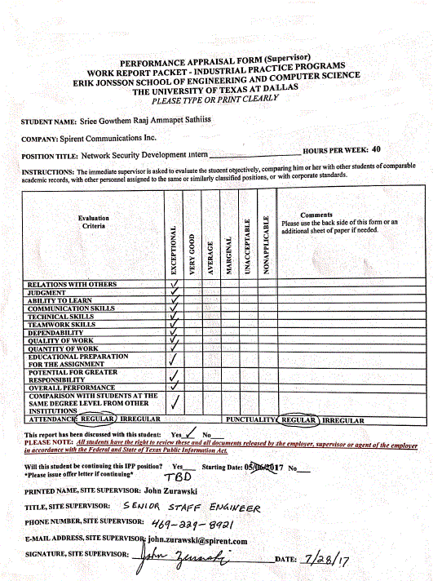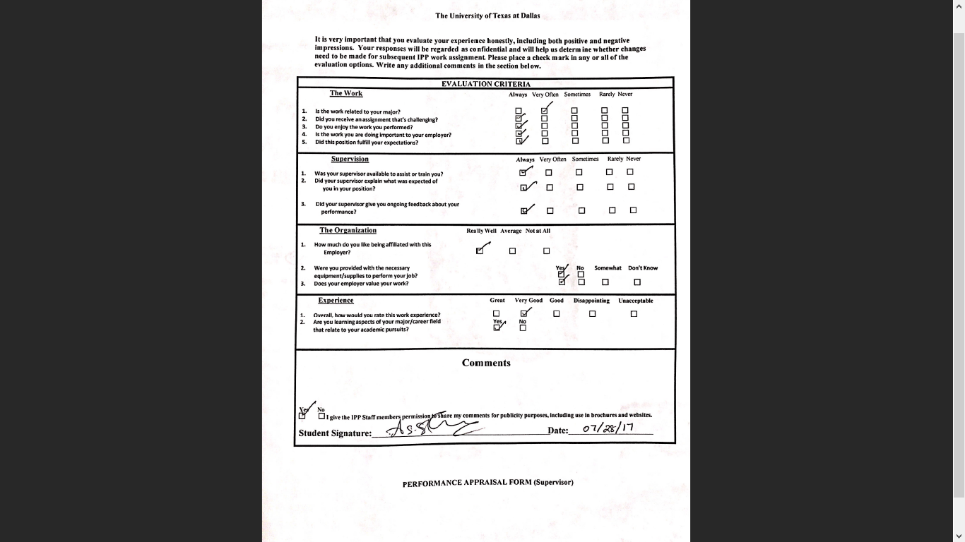

**Activity Description:**

I am a part of Application and Security Engineering Team, I am working on Spirent’s Advanced Fuzzing Engine product. My responsibility is to develop an Automation framework which will be used by the developers and third party contractors to identify bugs, measure performance of product’s running time and schedule batch jobs.

Spirent’s security products are aimed towards network security. Developers and third-party contractors work on network protocols fuzz testing mechanisms. This Automation framework is designed to be helpful to the above-mentioned entities.

Development Life-Cycle

My team is following Agile based sprints for their development. There are two meetings per week to report the status of our tasks and to discuss about features to work on. The Project Management team uses Altassian’s JIRA™ for assigning tasks and tracking its progress. The code base is mounted on GitHub.

Overview

Harley is the name given to the software which the engineers use to communicate with Spirent’s Advanced fuzzing engine. Fuzzing is a mechanism where you send malformed inputs to Device Under Test(DUT) to identify vulnerability in the device. In Spirent’s case these are network devices. The fuzzing engine produces malformed inputs per the protocol specification defined in the Requests for Comments(RFC). If a vulnerability is identified it presents it to the users to fix their device thereby preventing Zero day attacks. My task is to create a framework to interact with Harley to schedule jobs, measure performance and generate reports.

HATMS Framework

Harley Test Automation Management System (henceforth called as HATMS) is a framework used to generate reports and run batch jobs using the Harley front end. The overview of the Automation Management System with Harley is shown in the figure below.

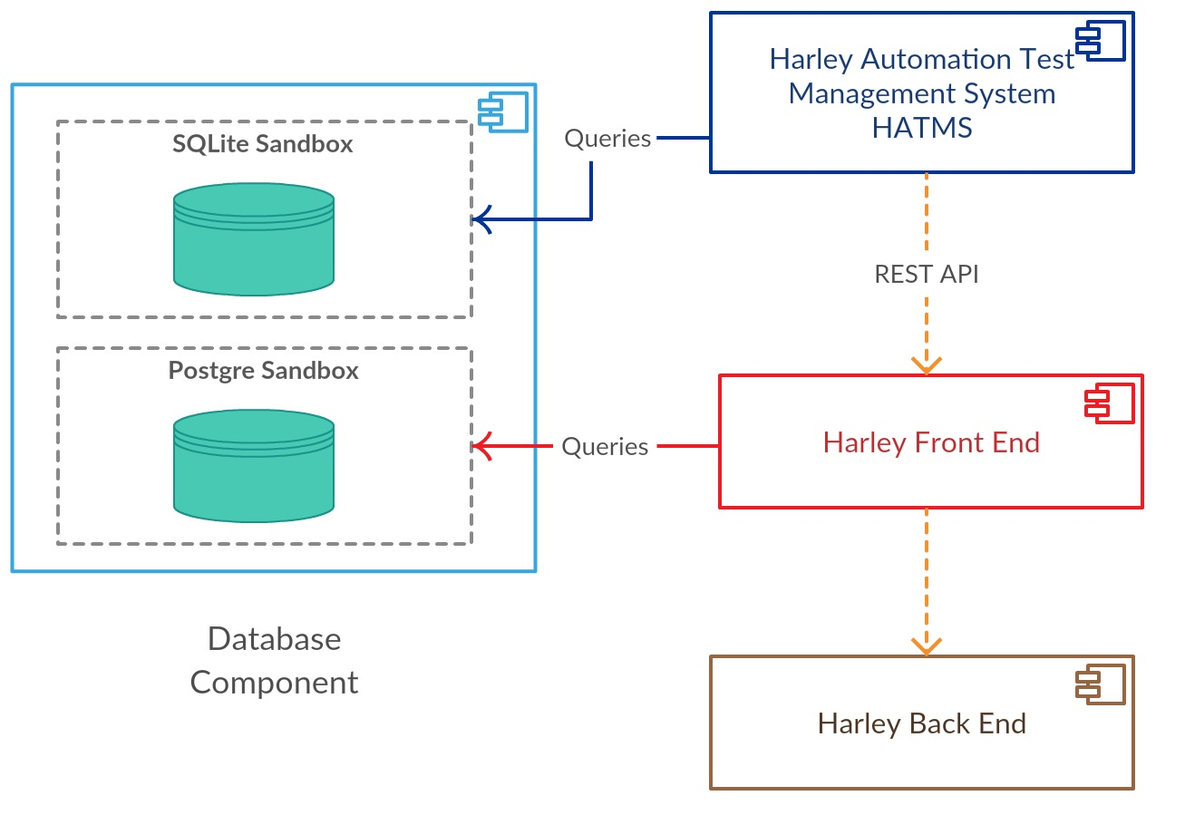

*Figure 1 Overview of Harley Test Automation System Framework (HATMS)*

Module 1 – Database

My first task is to build a database which will be used by other modules of the framework. Ensuring consistent data and synchronizing the database with the front end were the challenges associated with this module. HATMS gets its data from Harley front end which exposes REST API calls to fetch the data corresponding to ghost test framework. When HATMS starts, it checks for the availability of the database. If it does not find one, it starts to initialize the database with contents from the fuzzing framework. If it finds a database, it checks for any updates that needs to be synchronized and performs the update.

Initialization of the database uses multi-threading to create the tables and populate it with contents from the front end. Synchronization involves two databases – one used by HATMS and the other used by the Harley front end. Synchronization should ensure that these two databases are in perfect sync. If there are any inconsistencies, then the whole system will be in invalid state. An algorithm was devised to use time stamps and dirty flags to perform one way sync with the front end database. Profiling the database code showed that the total time take to populate the database was less than 31 seconds and for synchronization was about 18 seconds.

Module 2 - Report Generator

The second feature supported by HATMS was report generation. As part of the workflow, Developers were required to test their feature changes against all the protocols supported by Spirent (It was 68). They have option to choose from 6 types of test which varied in duration and mutation of the fuzz engine. It became tedious for the developers to run and test them one by one. It became much difficult for them to look at test cases which failed and to re-run them.

The report generation module provides solution for this problem. The developer can test only a subset of protocol’s that are requested by the client for the current release. Once they have tested with these protocols, they run the report generator module. The report generator module checks to see to what protocols the developers have tested against a release and what test cases passed or failed. It then starts creating a report which gives them a detailed view of the status of test cases for the release. Engineers can choose between HTML and JSON format for getting their output.

The generator also creates a job schedule which will be used by the scheduler (discussed next) to start batch jobs for the test cases which failed and for the protocols which were not tested for the release. Engineers have options to configure the type of report they like to generate. For Example: A user can select Status report for all the protocols for release 1.4. Using this tool users can create up to 16 combination of reports.One of the report which was helpful while presenting to the team was Version Summary. The report shows a detailed HTML document of the protocol tested against each test type, the date which it was tested and its status.

Module 2 – Job scheduler

The third feature of HATMS framework was the job scheduler. The job scheduler refers a configuration file to run batch of jobs. Users can either use the generator module (discussed above) or use a template to fill in the configuration file details. It has options to choose which protocols to include/exclude, the type of tests to run and on which development machine.

Once the user has specified the required configuration the scheduler then starts its execution. The scheduler first performs a *‘rain check’* to make sure that all the required files are present to perform the scheduling. Then it checks the state of the database. The state check is done to ensure that the database is in consistent state before the scheduler starts creating the jobs. It then checks two important configuration files – *settings* and *job template*. Since these are external files that could be modified during the execution of the program, it holds a lock on these files till the execution completes.

Scheduler after performing these checks uses the job template to create jobs and run them by interacting with Harley’s front end. The front end then creates multiple instances using VMware Vsphere API to start the jobs. The next task is to integrate the scheduler with Jenkins such that the entire process we discussed could be triggered automatically.

Module 3 – Performance measurement

The last feature of HATMS framework was performance measurement. The goal of this feature is to check whether there are changes in the run time of the program against each release. This helps to gauge performance of the product. Users input unique Id of each test case, the tool then looks for each of the unit test’s, measuring Iterations per mutation to calculate the speed. It then presents a detailed view on the command line. The output is formatted in such a way to replicate a *diff tool* (left vs right) format. The output display the time taken for each test case, its overall execution time compared to its previous release. Developers can use this data to identify the test case causing the difference, use the logs to find bottlenecks and then rectify them.

Technical specification

Python 2.7 was the language used for developing the HATMS framework. It uses Jinja2 template engine to generate dynamic HTML pages. Pythons JSON, multi-threading was used heavily. Sqlite3 was used for the Database. Users interacted with the HATMS framework through command line interface developed using argument parser module. VMWare VSphere was used as the virtualization platform. An open source API was used to interact with VMWare VSphere center to deploy virtual machines programmatically.

Analysis

Workflow

The workflow of the team was well structures. Project Management interacted with me regarding the feature to be implemented and wrote clear user stories. I could understand what was expected from me, what were my deliverables were and their deadlines. My mentor gave inputs regarding the way to structure the framework around configurations and explained in detail about the existing architecture and its pain points.

Design of framework

The design of framework was the crucial part, it should contain a data model which should scale as the test’s increase and should be configurable to make it as flexible as possible. During the first week, I was constantly brain storming ideas, white boarding the structure to my mentor. We would then discuss scenarios where it could fail, issues that will happen with scalability (The dataset is large and will be increasing).

I had prior failed experience with my design and had to rework to make it work. I wanted to avoid this scenario at all cost. I used my knowledge acquired from Database design & Advanced Operating Systems course to design fast and scalable system. The framework also has a unit test cases for each module to test its functionality. The code base is adhered to PEP8 Python style guidelines, such that it is easy for other developers to learn the code and understand its functionality. There is a documentation folder which explains in depth of each modules functionality. In addition to the documentation, there is *recipe* file which shows how to use the Harley Test Automation System Framework. The below figure shows the architecture of the framework.

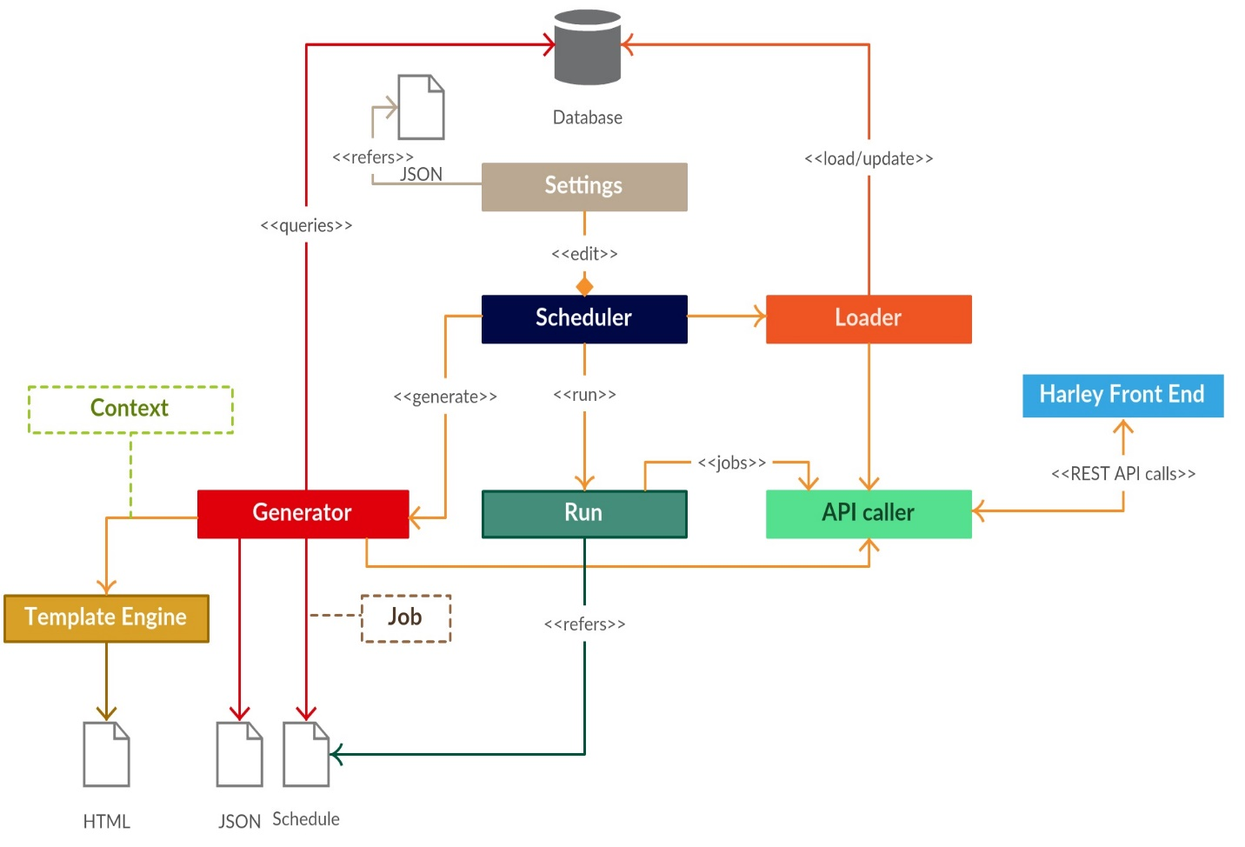

*Figure 2 HATMS Framework Architecture*